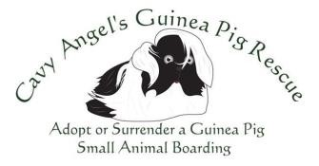

Cavy Angel's Guinea Pig Rescue Surrender contract agreement

Owners Details:
Full Name: ________________________ ________________________
Full Address: ___________________________________________________________
Contact Number: Mobile __________________ Home______________________
Email: ___________________________________________________________

Guinea Pig/s Details:
Name 1. ____________________________ Age/DOB 1 . __________________
Gender 1. ___________________ Neutered/Spayed 1. ___________________

Name 2. ____________________________ Age/DOB 1 . __________________
Gender 1. ___________________ Neutered/Spayed 1. ___________________

Name 3. ____________________________ Age/DOB 1 . __________________
Gender 1. ___________________ Neutered/Spayed 1. ___________________

I (Owner’s Name) ___________________________________________________hereby surrender (Guinea Pig/s Name) _________________________________________ to Cavy Angel's Guinea Pig Rescue and understand that by signing this form I am released from any previous commitments in regards to this animal. I understand that all rights to ownership of the above-mentioned Animal’s are now terminated and that Cavy Angel’s Guinea Pig Rescue will organize any care, medical treatments and re-homing needs.

Signed ___________________________ Date __________________________________

Cavy Angel's Guinea Pig Rescue.
Web: www.cavyangelsguineapigresuce.com
Email: monique-am2pm@hotmail.com
Ph: 0423238449

